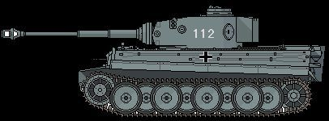
Figure 1Panzer leher
12th SS
+1

